Reading Aloud in a Church Setting
This factsheet is a summary based on the presentation and information given on the 8th November 2017 in a workshop on Reading for the Vienna Community Church.
There is also an accompanying video with this factsheet.
Summary of the night:
- We began the night by looking at our feelings when considering reading aloud. Some were positive and others less so. Below is the summary of what you came up with.
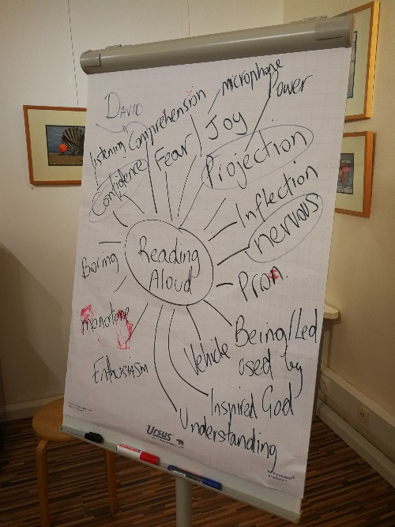
- Our first exercise, just asked you to go from your chair, to the lectern, back to the chair. This looked at your basic level and how you might normally walk around. It gave a base line to then suggest, what would 30% more look like? To achieve this, we thought about and breathed deep, that is through the nose, filling the chest and lungs to a fuller capacity.
The walking to the lectern exercise was then done again. Not only did more people smile, but there was a noticeable difference in the walk and the ‘energy’ of everyone. It was quite amazing to see just what a full breath can do for the body!
- The second exercise asked you to come from a standing position, to the lectern, say “Today’s reading is from Isaiah Chapter 2, verses 1 to 5.” Then return to your seat. This exercise gave you a chance to begin what we later called Step 1. Arriving. I think it is important no matter what you are reading to come as you are. You don’t have to interpret the reading from the first step you take. The congregation may not know what is coming next, so SMILE, be yourself and arrive. Be sure to check your glasses and other props are set up and you minimise the time it takes to begin. Look at the congregation and say the title of the scripture reading. This sets up who you are and it is also what we expect. Our brains unconsciously compare this to all other readings we have ever heard and then if we don’t match, our brains sound an alert!
We then broke away from the chairs and discussed neutral stance, which is what you can do to warm up your body and to shed the layers of onion of your personality and return to a natural form of yourself. This is important when you what to influence your vocal tone and projection. In brief, the neutral stance is –
Stand with feet parallel. Shoulder width apart.
Feel toes in shoes.
Knees bent over ankles. Not squatting but not locked knees. Locked knees are speaker death!
Hips are loose. Circle hip motion, in all directions.
This forms the core trunk. Like a solid tree. Grounded.
Top half sit on top of this foundation.
Belly can move in and out and tight stomach (holding it in) should be avoided.
Shoulders are loose
Arms hanging by your side.
Chin is level.
The eyes are forward.
Long in the back of neck.
Breathing through nose bring awareness to lower belly above belt buckle.
Place two fingers 1 inch below belly button.
Stomach and belly should move and bulge out on in-breath and go in on out-breath.
Take several breaths.
This allows you to set up your body in the best possible way to maximise your ability to remain calm, gain full deep breaths and to send your tone forward with confidence into the congregation.

There were several questions that arose during the meeting which I will do my best to remember and paraphrase as well as discuss potential answers. These included:
- What happens if you get nervous?
If you get nervous I would suggest simply breathing deep and feeling your toes in your shoes, this focuses your attention lower in your body and allows to you not think about being nervous. Also SMILE!
- What should I do if I make a mistake?
If you know you have made a mistake, then consider stopping, acknowledging that and then correcting yourself. Apologise and move on.
- Should I look at the congregation?
Only if you have memorised the text you are delivering. Perhaps at the end of the reading you could also look up to show you have finished.
- Are the congregation also reading alone, seeing if I am right?
If they are, they are, you cannot help that, but you want your vocal tone, variety and reading to be so convincing that people start to enjoy what you are saying and feel uplifted. You are giving the gift of your voice and reading to the congregation.
The remainder of the session also looked at vocal variety. This is particularly important when we read. Try to adjust the…
- Tempo – the speed at which you read phrases and words
- Pitch – the height or tone of the notes you speak (we are all musical instruments!)
- Volume – adjust how loud and soft you make phrases and words and don’t be afraid to change suddenly and mid-sentence if it suits the text.
- Emphasis – stress individual words and phrases. If a word is repeated then do something different with it for effect. Make things interesting. Of course, we need to understand the text to do this.
- Narrator Voice vs. Character Voice – try to make a distinction between a Narrator tone and emphasis and a character. When you see “ “ in the text, this means you should evoke a character. See what you can try.

We finished the session by all taking the opportunity to put our skills in practice, to read Psalm 122 in whatever way we wished.
It was wonderful to see so many take-on one or several inputs and developments from the session and put them into practice.

Good luck with your reading and if you would like to connect with me further or have any questions, please do not hesitate to contact me at:
Resonant Personal Development
www.resonantpd.com
david.corcoran@resonantpd.com
+43660 629 1836
And at church on Sundays! I am always in the Choir.

Extras!!
The rest of this document, discusses in a bit more detail with another exercise or two, material I had prepared for another workshop and have adapted for a church setting that you might find useful!
Breath – Breath is life, but it also forms the musical instrument that is your voice. Whether you realise it or not, your voice is a gift to others and reading aloud can be tremendously rewarding. But you must breath well. Short breaths will make others feel anxious, breathing in the wrong spot will also not help the listener understand what you are saying. So pay attention to our next point, punctuation.
As an exercise, take a shallow quick breath and try to read a whole paragraph. Now take a larger, full belly breath and read the same sentence. Not only will you feel calmer, but you will have more energy to give and more time to use the other elements mentioned in this section.
Punctuation – According to the Oxford dictionary, these are the marks (like the full stop, comma and brackets) used in writing to separate sentences and their elements and to clarify meaning. This last part, clarify meaning is important. Through correct use of punctuation, you create meaning for the listener when you read aloud. My English teacher used to say 1 second for a comma and 2 seconds for a full stop. Observe the punctuation and you create moment of pause, our next top reading element.
As an exercise try avoiding punctuation altogether. Go the other way now and see if you make too much of punctuation whether the energy drops. There is a fine balance between both.
Pause – This is something to be used for punctuation and dramatic effect. It is the space between the words that give the words their meaning. Like a piece of music, the space between informs our ears of what is going on.
As an exercise try reading a whole paragraph without pausing, maintaining the same speed and tempo throughout and see if you audience understands you!
Projection – One of the first things people will notice about you when you read aloud, is whether you can be heard or not, so make sure you project your voice. You do not need to yell but it is important to think about filling your surrounding space. Can you hear yourself in the church? Does your voice come back to you easily? This is a clue as to whether you need to increase your breath and volume or whether you can take it easy and allow your voice to travel through the space. Match this and you are well on your way to being heard without problems.
Vocal Variety – One of the most common complaints people make to me about their voices is that someone told them they sound monotone and unfortunately, they are probably right. How you use your voice is critical to your reading success and it separates the readers from the sentence leaders!
Imagine yourself as a robot reading scripture. How would you make it sound?. Monotone and a little creepy. For some people, their reading is somewhat similar. Now try reading like an Opera Singer or a News Host. Be dramatic with your voice and play with what you are reading. We all have a full spectrum of sound within us, so make things stand out. Decide which words to emphasise and where to place the word stress. If you are not sure about a word, ask someone about it. Otherwise your incorrect reading of a word will stick out especially if it comes multiple times in the text.
Emotional Reactions of the Characters – This is the final element worth considering when reading aloud. Once you have mastered your breath, can punctuate and pause and have good projection and vocal variety, you can become specific with the emotions of the characters. What can you inject from your own emotional experience that is similar to what the character is feeling?
As an example, if you have a bible passage to read, try reading it in an overly emotional way. Imagine you are on the verge of tears with the verses. Now try the same statement in a stern and emotionless way. Which one feels more correct? If you are reading a play or scene from theatre the emotional intention might already be written for you but honour it. Don’t ignore the authors emotional intentions. Likewise, it might be suggested in the bible. Use words pictures to tell the story. If a phrase is repeated, make something new of it each time you say it, or say it the same but with a slight difference.

